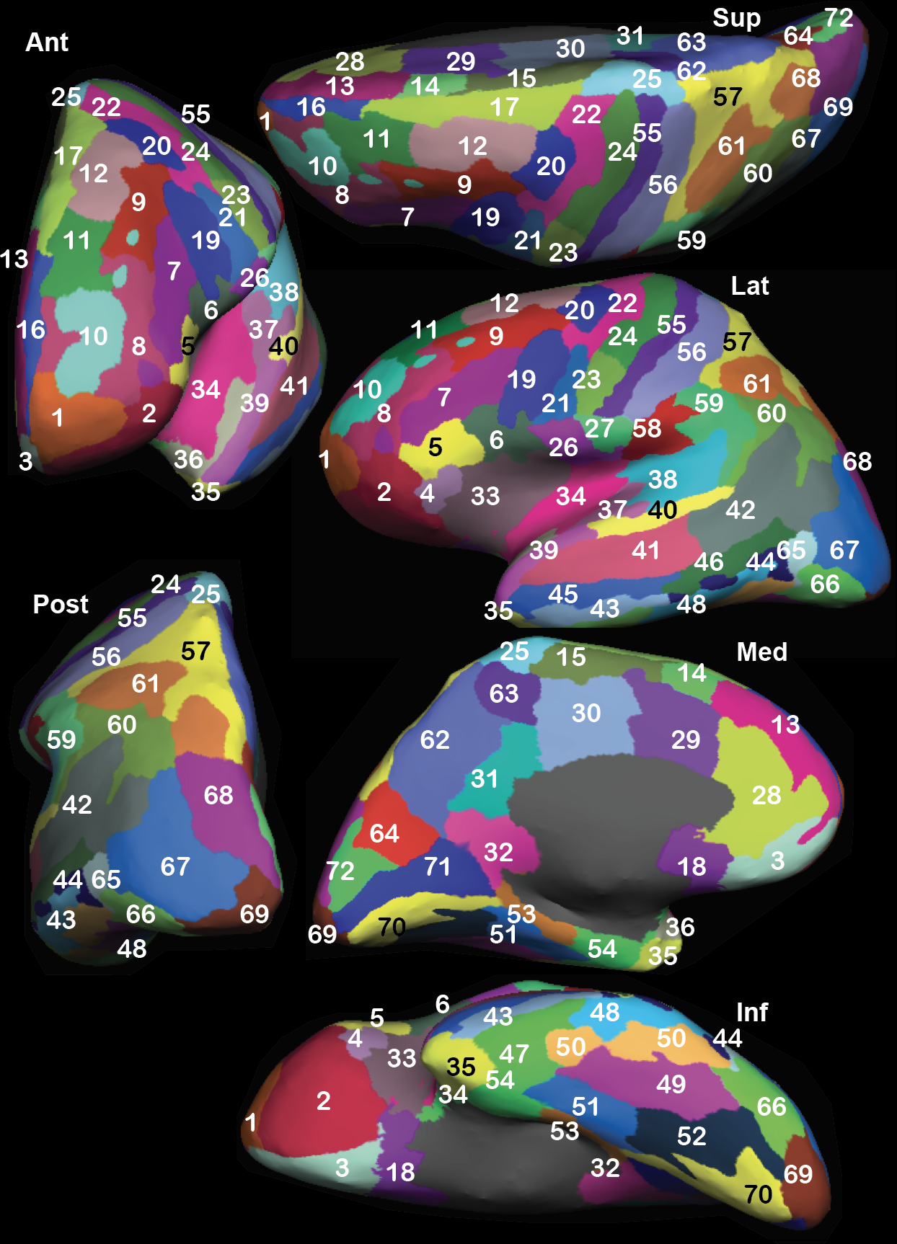

Figure 1 **Inflated view of VEP parcellation of left hemisphere of a patient.** Numerical indices refer to the anatomical regions defined in Table 2: superior (Sup), anterior (Ant), lateral (Lat), posterior (Post), medial (Med), and inferior (Inf) views are provided. Both gyral and sulcal cortices are visible on this representation.

­­­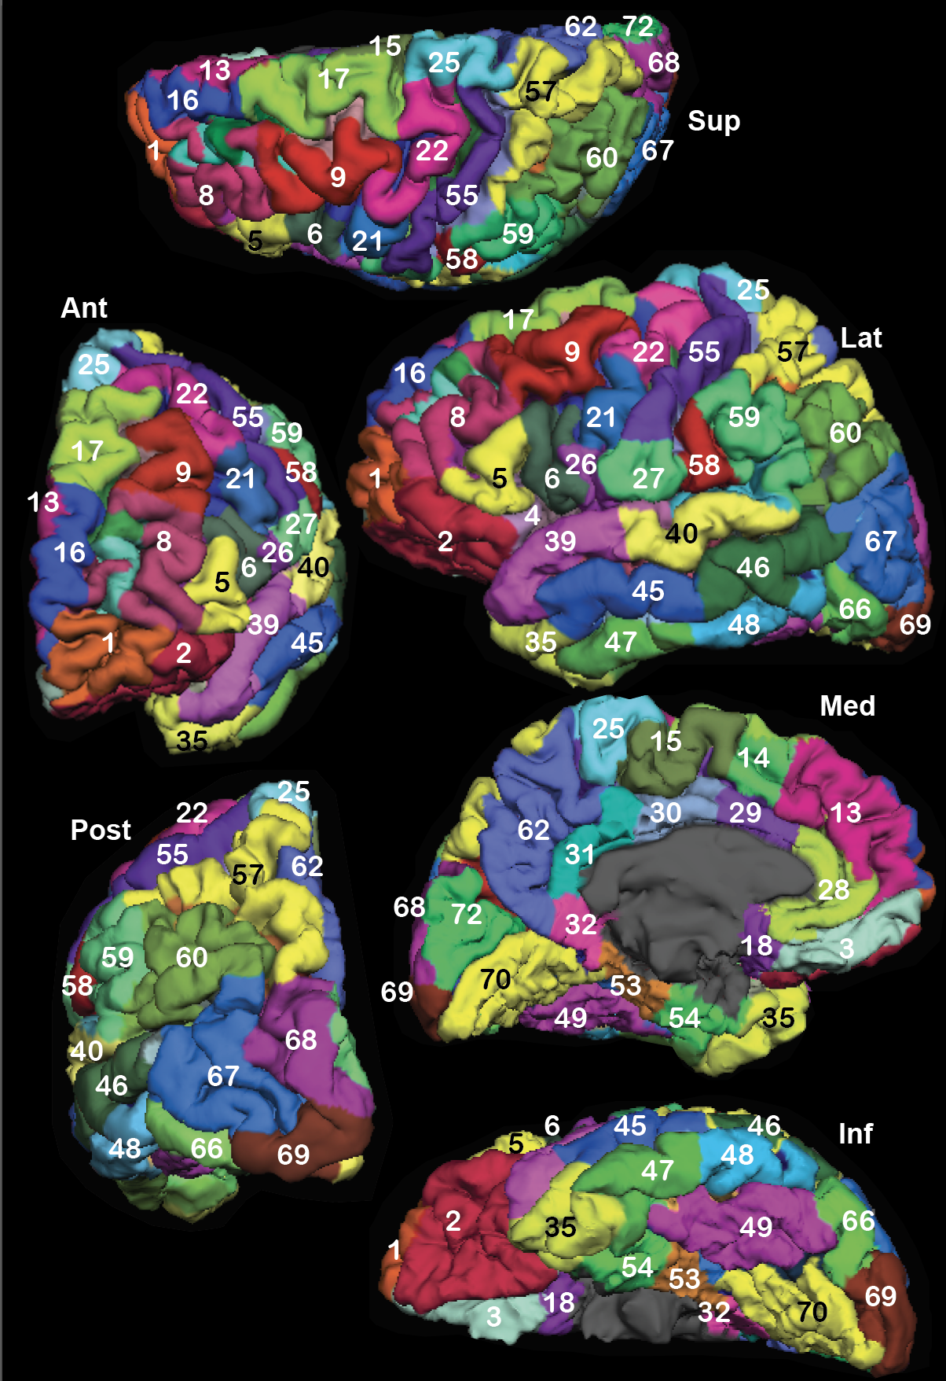­­­

Figure 2 **Pied view of VEP parcellation of left hemisphere of a patient.** Numerical indices refer to the anatomical regions defined in Table 2: superior (Sup), anterior (Ant), lateral (Lat), posterior (Post), medial (Med), and inferior (Inf) views are provided.

# APPENDIX: VEP parcellations

Table 2: List of anatomical VEP parcellations.

|  |  |  |
| --- | --- | --- |
| **Index** | **Region names** | **Visible on views** |
| 1 | Frontal-pole | Ant, Sup, Lat, Inf |
| 2 | Orbito-frontal-cortex | Ant, Lat, Inf |
| 3 | Gyrus-rectus | Ant, Med, Inf |
| 4 | F3-Pars-Orbitalis | Lat, Inf |
| 5 | F3-Pars-triangularis | Ant, Lat, Inf |
| 6 | F3-pars-opercularis | Ant, Lat, Inf |
| 7 | Inferior-frontal-sulcus | Ant, Lat, Sup |
| 8 | F2-rostral | Ant, Sup, Lat |
| 9 | F2-caudal | Ant, Sup, Lat |
| 10 | Middle-frontal-sulcus | Ant, Sup, Lat |
| 11 | SFS-rostral | Ant, Sup, Lat |
| 12 | SFS-caudal | Ant, Sup, Lat |
| 13 | F1-mesial-prefrontal | Ant, Sup, Med |
| 14 | PreSMA | Sup, Med |
| 15 | SMA | Sup, Med |
| 16 | F1-lateral-prefrontal | Ant, Sup, Lat |
| 17 | F1-lateral-premotor | Ant, Sup, Lat |
| 18 | Subcallosal-area | Med, Inf |
| 19 | Precentral-sulcus-inferior-part | Ant, Sup, Lat |
| 20 | Precentral-sulcus-superior-part | Ant, Sup, Lat |
| 21 | Precentral-gyrus-head-face | Ant, Sup, Lat |
| 22 | Precentral-gyrus-upper-limb | Ant, Sup, Lat, Post |
| 23 | Central-sulcus-head-face | Ant, Sup, Lat |
| 24 | Central-sulcus-upper-limb | Ant, Sup, Lat, Post |
| 25 | Paracentral-lobule | Ant, Sup, Lat, Med, Post |
| 26 | Central-operculum | Ant, Lat |
| 27 | Parietal-operculum | Ant, Sup, Lat |
| 28 | Anterior-cingulate-cortex | Sup, Med |
| 29 | Middle-cingulate-cortex-anterior-part | Ant, Sup, Med |
| 30 | Middle-cingulate-cortex-posterior-part | Sup, Med |
| 31 | Posterior-cingulate-cortex-dorsal | Sup, Med |
| 32 | Posterior-cingulate-cortex-retrosplenial-gyrus | Med |
| 33 | Insula-gyri-brevi | Lat, Inf |
| 34 | Insula-gyri-longi | Ant, Lat, Inf |
| 35 | Temporal-pole | Ant, Lat, Inf, Med |
| 36 | T1-planum-polare | Ant, Med |
| 37 | Gyrus-of-Heschl | Ant, Lat |
| 38 | T1-planum-temporale | Lat, Ant |
| 39 | T1-lateral-anterior | Lat, Ant |
| 40 | T1-lateral-posterior | Ant, Lat |
| 41 | STS-anterior | Ant, Lat |
| 42 | STS-posterior | Lat, Post |
| 43 | ITS-anterior | Lat, Inf, Post |
| 44 | ITS-posterior | Lat, Inf, Post |
| 45 | T2-anterior | Lat, Inf |
| 46 | T2-posterior | Lat, Inf, Post |
| 47 | T3-anterior | Lat, Inf |
| 48 | T3-posterior | Lat, Inf, Post |
| 49 | Fusiform-gyrus | Inf |
| 50 | Occipito-temporal-sulcus | Inf |
| 51 | Collateral-sulcus | Med, Inf |
| 52 | Lingual-sulcus | Inf |
| 53 | Parahippocampal-cortex | Med, Inf |
| 54 | Rhinal-cortex | Med, Inf |
| 55 | Postcentral-gyrus | ﻿Ant, Sup, Lat, Post |
| 56 | Postcentral-sulcus | Lat, Sup, Post |
| 57 | Superior-parietal-lobule-P1 | Sup, Lat, Post |
| 58 | Supramarginal-anterior | Ant, Lat, Post, Sup |
| 59 | Supramarginal-posterior | Ant, Sup, Lat, Post, |
| 60 | Angular-gyrus | Lat, Post |
| 61 | Intraparietal-sulcus | Lat, Post |
| 62 | Precuneus | Med |
| 63 | Marginal-branch-of-the-cingulate-sulcus | Med, Sup |
| 64 | Parieto-occipital-sulcus | Sup, Med |
| 65 | Anterior-occipital-sulcus-and-preoccipital-notch | Post, Lat |
| 66 | O3 | Lat, Post, Inf |
| 67 | O2 | Sup, Lat, Post |
| 68 | O1 | Sup, Lat, Post |
| 69 | Occipital-pole | Sup, Lat, Med, Post |
| 70 | Lingual-gyrus | Med, Inf |
| 71 | Calcarine-sulcus | Med |
| 72 | Cuneus | Med, Sup |
| 73 | Hippocampus-anterior |  |
| 74 | Hippocampus-posterior |  |
| 75 | Amygdala |  |
| 76 | Thalamus |  |
| 77 | Caudate-nucleus |  |
| 78 | Putamen |  |
| 79 | Pallidum |  |
| 80 | Nucleus-accumbens |  |
| 81 | Cerebellar-cortex |  |